Mathematical Investigations III

The World Upside Down

Review and Practice

1. Write an equation for a rational function that reduces to a linear function for all x ≠ –5, has a "hole" in the graph at (–5,8) and a y-intercept at –7.

2. Sketch the graphs of the reciprocals of the given graph.

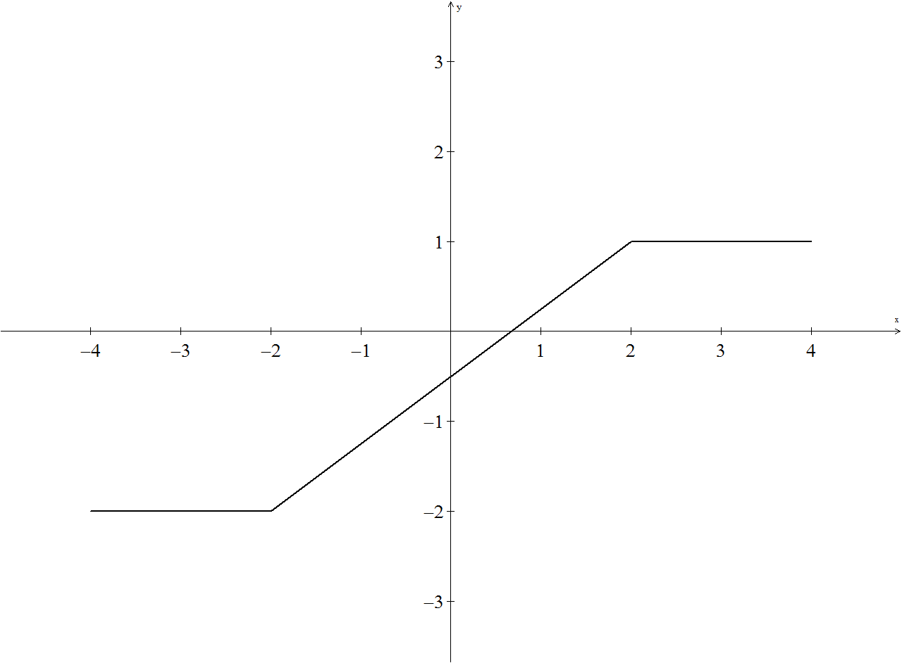
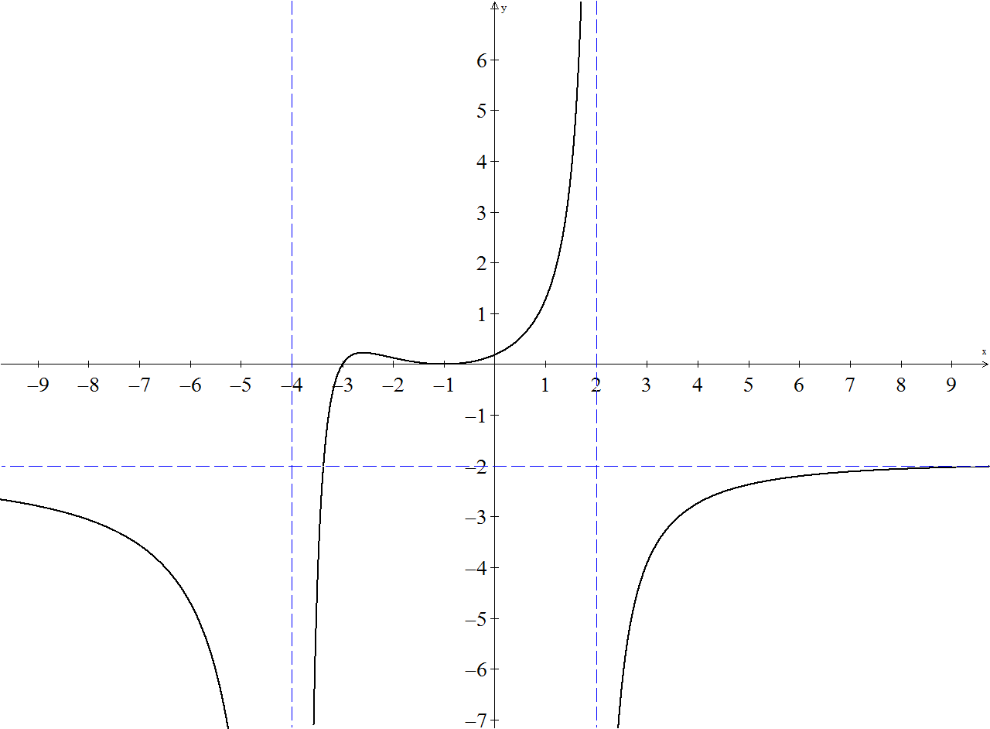

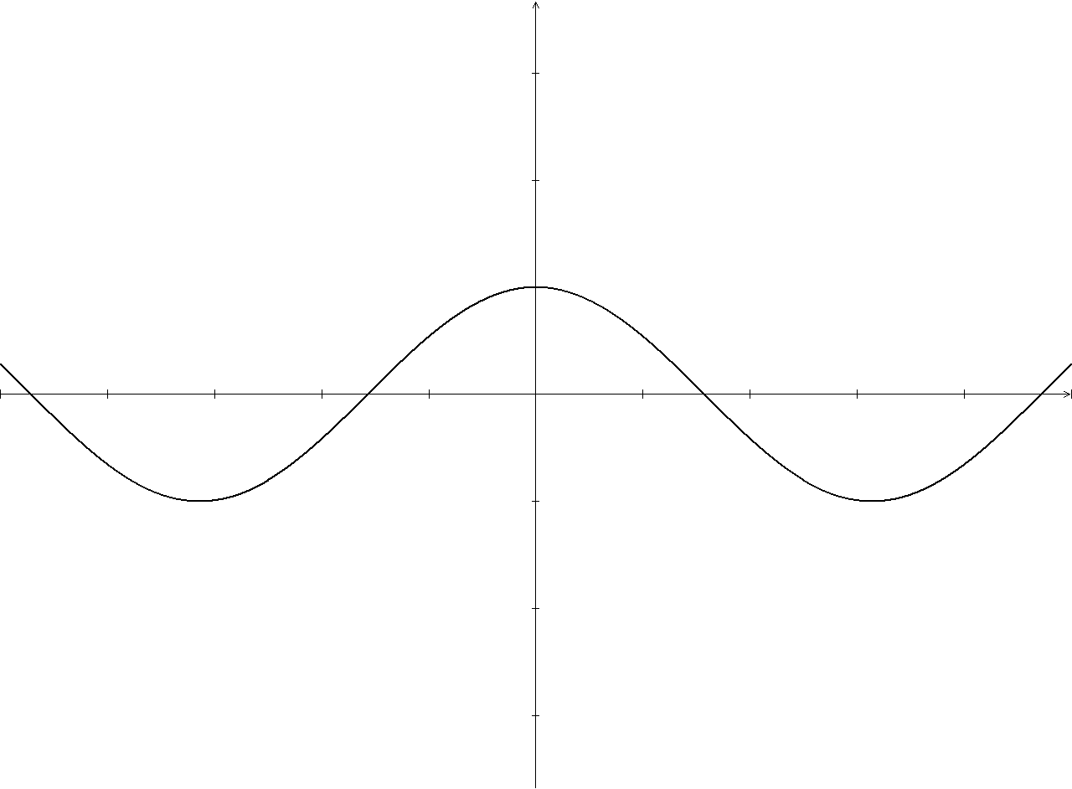
3. Write the equation for the rational function sketched below.

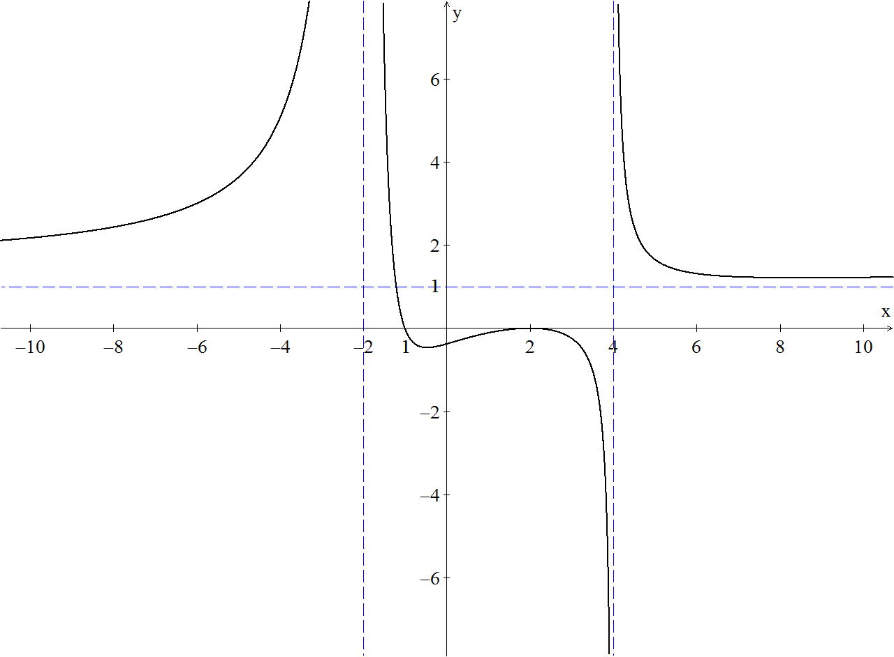

Graph each of the functions given. Label all key features, including asymptotes, holes, intercepts, where the graph crosses a horizontal asymptote, and other important points.
y
x
7
25
-20
-5
4.

5.
y
x
5
5
-5
-5

6.
y
x
5
15
-15
-7

Choose your scale appropriately on these.
7.

8.

9. Find the equations of all asymptotes of each of the following.
a.

b.

10. Write an equation of a rational function, R(x), with the following characteristics:
zeros at 3 ± 4i, a bounce point at x = 2, a horizontal asymptote at y = 0.5, and
a vertical asymptote at x = 0 where .

